Garden Cottage

i. General

Garden Cottage is a very handsome symmetrically arranged one-and-three quarter storey building of three principal bays. It is north-south aligned and the principal frontage faces Loch Fyne to the west. The building seems to have been recorded on the 1870 Ordnance Survey Map (First Edition at 6 inch scale), with a small extension at the rear.

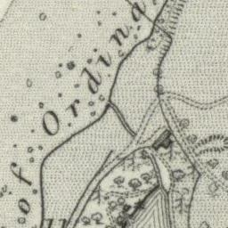 | 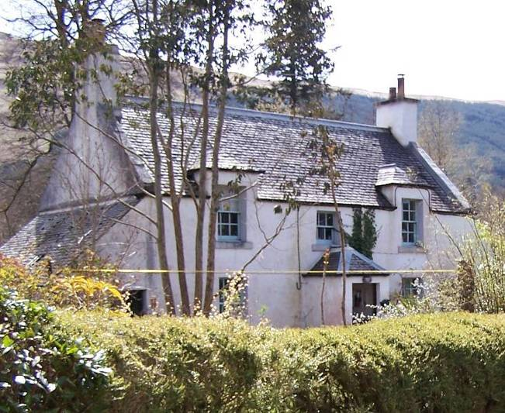
Figure 4: 6 inch Ordnance Survey Map, First Edition 1870. National Map Library of Scotland. | Plate 32: W elevation of Garden cottage, from the road in NW.
There appears to have been a building here in the census records from the mid to late 19th century and it is not readily apparent how much of the existing building may be based on an earlier structure. Certainly the gable wallheads are finished with stone scewparts and these may be elements of an earlier building or perhaps reused. However, if the present structure is based on an early building, it has been very extensively remodelled and it is well known that this was undertaken by Robert Lorimer in the early part of the 20th century. Certainly the woodwork and many of the details appear to be of this period. Window cills, for example, appear to be formed of cast blocks of cement.

Garden cottage is occupied by Julie and Glyn Toples.

ii. Exterior

The house overall is under a double-pitched slated roof. The slates appear to have been discoloured by lichen that is very extensive in some areas; in other areas it is very clear is the very dark grey slates of West Highland type of silvery-blueish hue are typical of the Luss highland line series. The building is harled externally and painted white throughout. Surmounting the gables to the north and south are double chimneys, each with a pair of pale ceramic chimney cans. To the north and south are single storied lean-to sheds whose single pitched roofs rise up to the wallhead level. At the centre of the principal frontage there is a small hip-roofed porch with entrance to the west. The windows are arranged symmetrically in relation to this with pairs on ground and first floor level and a small central window above the porch. The outer two first floor windows rise up to dormant heads that are hipped and slated rising to lead rolls at the apex, and the apex of the main roof itself pure leaded roll.

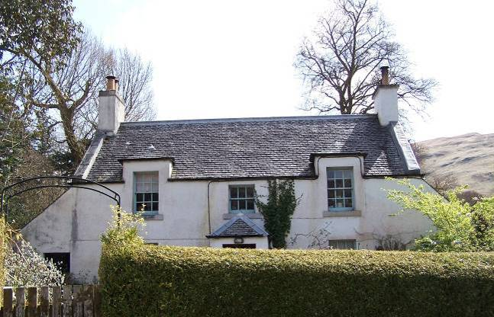 | 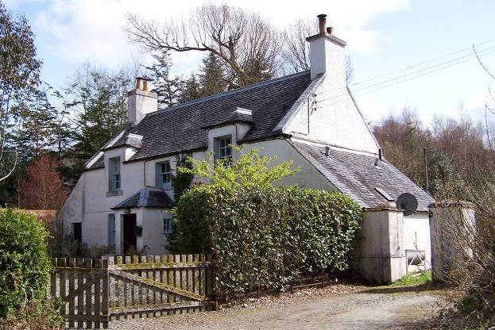
Plate 33: W elevation. | Plate 34: W elevation of Garden cottage, from the road in SW.
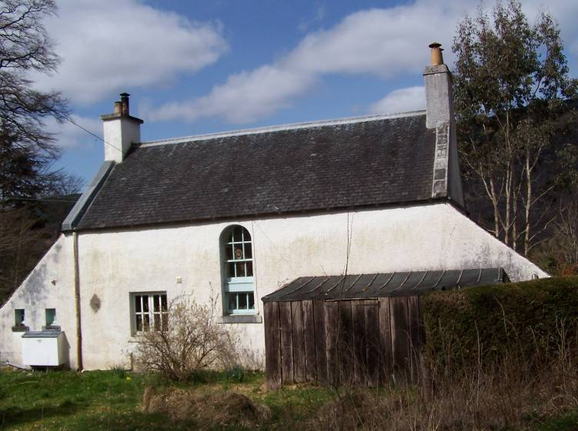 |  | 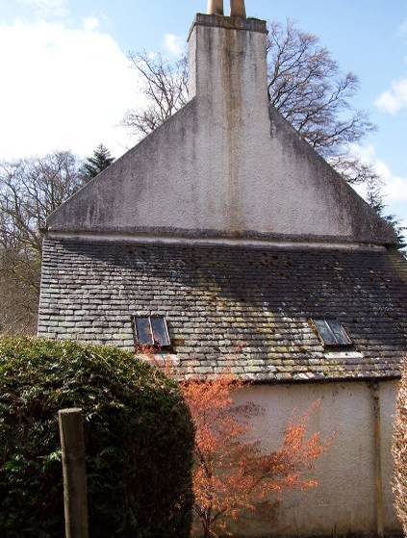
Plate 35: E elevation from garden. |  | Plate 36: Northern lean-to structure.
Externally, the window joinery is all painted in a pale blue. All of the wallheads and dormerheads are furnished with cast rainwater goods. The centre of the rear elevation to the east is a tall stair window; this with an arched head and offset to the south. There is a further large window at ground floor level to the S, most likely a later insertion. The lean-to structures on either side in N and S appear to have been accessed from the exterior by entrances in the west elevation. While the door in the N lean-to structure is still extant, the entrance to the southern lean-to a[[ears to have been partly filled in subsequently and formed into a window. The southern lean-to also has two small windows in the east wall and a further modern window in its south wall towards the south-east corner.

The northern lean-to structure has no fenestration in the walls and is simply lit by two small cast iron skylights. The westernmost part of this lean-to structure appears to be a shed interior, not accessed. The northern lean-to appears to be of two phases, which indicates that he S lean-to might be of similar phasing. The western two-thirds of the northern lean-to appears to be a rubble mortar bonded construction and it is clear that this has been extended to the full width of the main house by an eastwards addition, furnished with an entrance in the east wall. The interior has clearly functioned as a coal house. The extension is brick-built of coarse pale-creamy terracotta bricks set in a hard grey lime mortar. Built up against the northern part of the rear eastern wall of the building is a more recent timber framed lean-to woodstore.

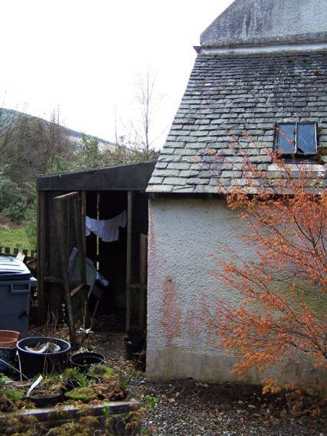 | 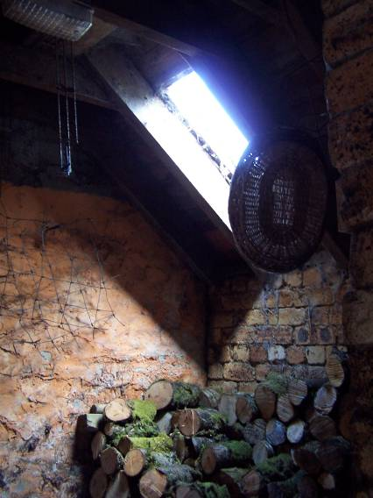 | 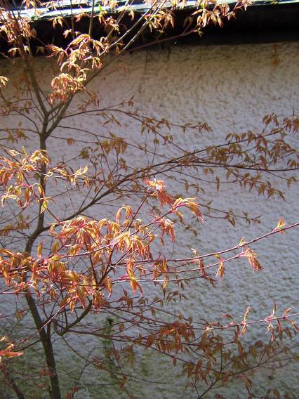
Plate 37: N lean-to and wooden shed to E. | Plate 38: Rooflight in E part of N lean-to. | Plate 39: Crack in wall of northern lean-to structure at joint of E and W part.

The northern extension has roughcast over it. This detail of this is consistent with that of the main house. This roughcast covers the entire elevation apart from a small band towards the wall foot which is rendered flat. This harling detail at the wall foot extends all the way around the building and appears likely to be a Lorimer detail. The fact that the apparently earlier western part and the later eastern part of this lean-to structure are finished with the same Lorimer detailing suggests that the earlier rubble masonry part is earlier and thus must be pre-Lorimer in date. It also suggests that the eastern extension was probably added by Lorimer. A crack in the external harling at the point where the western and eastern parts join confirms the two phases for the lean-to, although the 1870 map is not precise enough to clarify this detail.

There is a pair of gate piers contiguous with the west frontage extending out from the south-west corner. These have low pitched pyramidal tops and are harled in cement and painted white, but the harl is falling away to reveal a lime-bonded rubble work core. The western north and north-west parts of the surrounding area are an attractive garden area within boundary hedges.

iv. Interior – Ground Floor

The porch interior has a quarry tiled floor of 9 inch pale-orange terracotta tiles. The principal entrance within the porch contains a hardwood door very substantially constructed of vertical boards apparently teak or similar exotic. There are some fixtures and fittings that have since disappeared but surviving is the housing for a chain lock. This is an elaborate cast iron detail. There is a simple and chronologically later box lock above. The porch area leads into a small entrance vestibule. In this area the lower walls are aligned with vertical match boarding. The upper walls appear to be plaster boarded. The whole area is concrete floored and leads directly to a stairwell which is a straight flight rising up to the east and a small landing. This then splits and there are further shorter flights rising up to the north and south respectively on upper floor level. The wall faces within the stairwell are detailed with a dado moulding run within the plasterwork within the partitions. This may be very similar to such details at the Lorimer Cottage (kennels), but there the moulding sits at a lower height along the stairs.

The entrance vestibule leads off to the principal ground floor rooms to the north and south. The northern ground floor room is lit by a single large window to the west. This contains a sash-and-case with six-over-six panes, with glazing bar profile a broad fillet-and-ovolo moulding. The doors into the two ground floor rooms are painted but appear to be teak, but could possibly also be pine, similar to the door to the south room (see below). They are four panelled with a narrow rounding of the inner angles on both sides. There is some evidence for door furniture partly overpainted and partly missing. The ground floor room to the north has good tight three inch pine boarding. There is a fireplace in the centre of the north wall. This is of pale ceramic small bricks and a hearth area in front which is tiled. At the west end of the north wall there is a wall press, now without a door but with shelving remaining within. This is lined out vertically with three inch boarding, detailed with a bead at the joint.

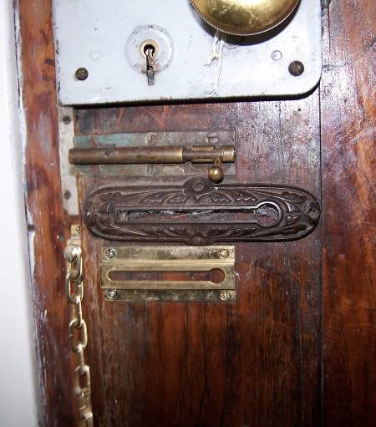 | 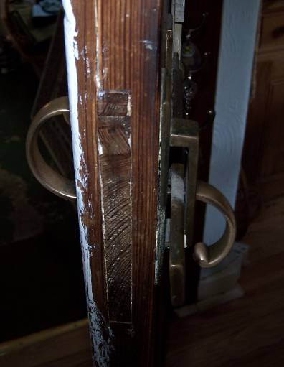 | 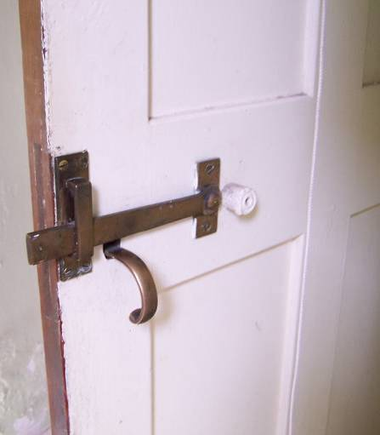
Plate 40: Detail of door lock on main entrance door. | Plate 41: Detail of door handle in N room  (ground floor). | Plate 42: Detail of door handle on door connecting kitchen and S lean-to structure.

The southern ground floor room is the present kitchen. The walls are plastered throughout except to the east and west where there is vertical boarded dado panelling rising up to a simple rail above. The door from the entrance vestibule is varnished at the back, not painted, and this reveals it to be a high quality red pine, and it is likely that the door opposite. In the north room, is likely to be pine, too. The kitchen door is detailed with a very good heavy brass latch with characteristic Lorimer detailing, which is also seen at Lorimer Cottage (kennels). The kitchen interior is lit by one original window in the west frontage, this again with a six-over-six sash-and-case window lined out internally with boarding, simple architrave around. In the east elevation is a window newly inserted (about 2004-5). This has a central mullion and two cases within each, two-over-two. The southern case is hinged on the south side.
At the east end of the north wall there is a further entrance, again with a good heavy brass latch and small gothic keyhole plate above. The door is in original varnished condition and leads to an under-stair pantry. The pantry is lit by a window in the east wall. This is the continuation of the arched window in the stair immediately above at the upper level. At the centre of the south wall there is an existing fireplace. This is built of small bricks, there is a raised tiled hearth area below. At the south-east corner the angle is framed out. There is a boiler arrangement within.

Until about 1985 the present kitchen had functioned as a sitting room/kitchen, the kitchen also occupying the lean-to building against the south gable wall.

At the west end of the south wall there is a further four panel door leading into the former kitchen interior in the lean-to structure. The kitchen interior extant in the lean-to no longer retains many kitchen fittings. The range appears likely to have been in the north wall. Interiors are rendered out. The chamber is lit by a three over three windows in the west wall and a small skylight in the south. The lean-to internally is subdivided by a north-south aligned partition. This contains a four panelled Lorimer door with brass door furniture. The thickness of the wall indicates that it is likely of brick work. There may formally have been an external entrance on the east side although this is now filled in. Concrete flooring throughout and some modern utility units and a shower are installed in the eastern compartment. The shower itself overlays a pre-existing window which can be seen externally.

iv. Interior – First Floor

At first floor level, the stair window contains a sash-and-case window six-over-three panes and no attempt to fanlight the top. Angles within the stairwell area are all rounded. Entrances lead off after a single step from the stair landing to the north and south. These each containing a four panelled door with similar brass latches as elsewhere.

The room to the south is lit by a single large dormer window to the west. This room contains a fireplace in the south gable wall, an elongated tall cast iron surround with iron mantle shelf over it and cast low fender around the hearth stone. At the west end of the north wall there is a further four panelled door leading into a small dressing room or closet. This is lit by the window in the centre of the west façade above the porch, plastered internally.

Plate 43: N lean-to and wooden shed to E. | Plate 44: Rooflight in E part of N lean-to. | Plate 45: Crack in wall of northern lean-to structure at joint of E and W part.

The northern upstairs room is plastered throughout internally, used as a bedroom. In the north wall, slightly offset to the west, is a fireplace. This a relatively recent feature, formed of ceramic tiles with a tiled hearth area beneath. The tiles are in pale grey and dark grey. The room is lit by a window in the centre of the west wall. This has broad fillet-and-ovolo moulding profile. A broad recess has been made in the south wall .

